**Exp No: 6 Applying DML commands**

Data Manipulation commands are most widely used SQL commands and they are

• Insert

• Update

• Delete

• Select

**Query:**

use testdb;

drop table student;

create table student_details(roll_no int, student_name varchar(100), branch char(3));

desc student_details;

alter table student_details

add primary key(roll_no);

desc student_details;

**#Insert**

insert into student_details values(1, 'Nitisha', 'cse');

insert into student_details values(2, 'Rachana', 'cse');

insert into student_details values(3, 'Keerthi', 'cse');

select * from student_details;

**Output:**

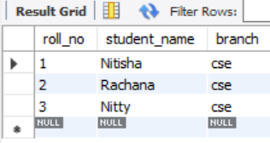

**#Update**

update student_details

set student_name = 'Nitty'

where roll_no = 3;

select * from student_details;

**Output:**

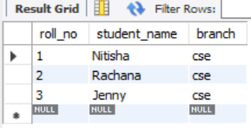

**#Delete**

delete from student_details where roll_no = 2;

select * from student_details;

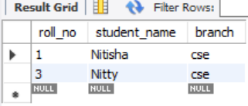

**#Select**

select student_name, roll_no from student_details;

**Output:**

